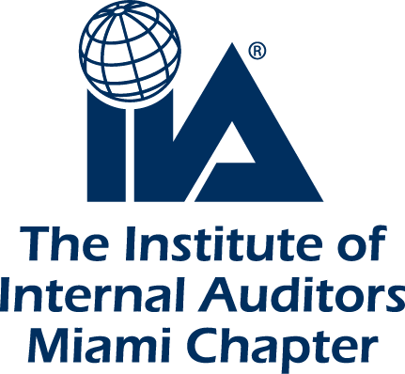
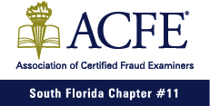
2019 CONFERENCE
“T.G.I.F.: Thank Goodness its FrauDay”

Date: Friday, March 29, 2019
Location: Kovens Conference Center – FIU Biscayne Campus
Address: 3000 Northeast 151st Street, North Miami, FL 33181

7:30 AM – 8:30 AM | Registration & Breakfast
8:30 AM - 8:35 AM | Welcome & Introduction (IIA 2019 Team)  Hadas Mizrahi - President, IIA Miami Chapter  Janine Wolman - Programs Committee, IIA Miami Chapter  Alan Blass - President, South Florida Chapter of Certified Fraud Examiners
8:35 AM - 9:30 AM | Session 1: Imprisonment to Empowerment - Leverage Your Past to Empower Your Future  Kevin McCarthy, Immediate Past President at National Speakers Association - Oregon Chapter
9:30 AM - 10:30 AM | Session 2: Business Security, Fraud Prevention and Investigation  Ed McDonough, Chief Security Officer, ADT
10:30 AM - 10:45 AM | Break 1
10:45 AM - 12:00 PM | Session 3: When Good Leaders Lose Their Way  Mark & Ginger Whitacre, COO at CBMC, COO & Chief Science Officer of Cypress Systems, Inc.
12:00 PM - 12:50 PM | Lunch
12:50 PM – 1:00 PM | ACFE Annual Scholarship Award Winners  Alan Blass, President, South Florida Chapter of Certified Fraud Examiners
1:00 PM - 2:00 PM | Session 4: Fraud-Resistant IT Project Deliverables  Lawrence “Martin” Capuder, Managing Director, ConsultantC.Services
2:00 PM - 2:45 PM | Session 5: Shedding Light on the Dark Web  Wanda Archy, Cyber Intelligence Specialist, RSM
2:45 PM - 3:00 PM | Break 2
3:00 PM - 4:30 PM | Session 6: Was It Fraud? If So, Who Did It?  Dave Cotton, Chairman at Cotton & Company LLP
4:30 PM – 5:00 PM | Session 7: Questions Panel  Rachel & Kevin McCarthy / Mark & Ginger Whitacre
5:00 PM - 7:00 PM | Conference Reception in the remarkable patio of the Kovens Center (FIU)  Complimentary hors d’oeuvres, beer and wine

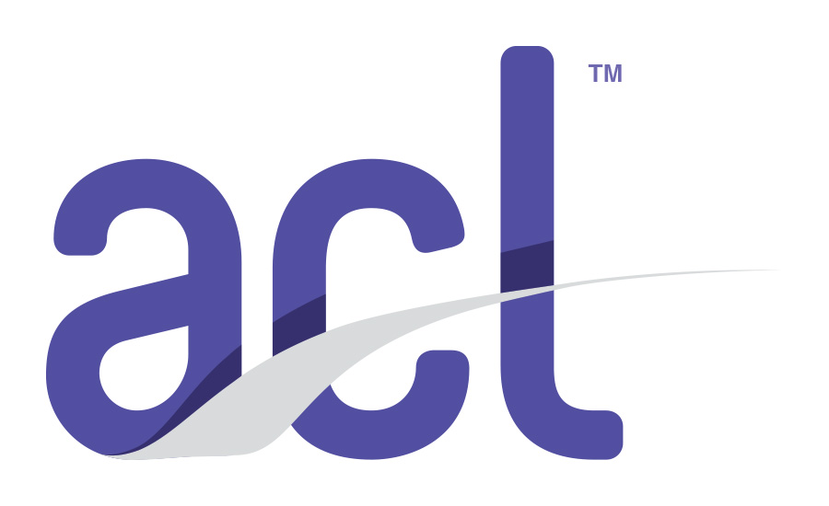
Thank you to our sponsor:

