ACFE and ACAMS South Florida Chapter

2017 AML/Fraud Conference

**November 3, 2017**



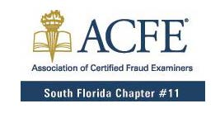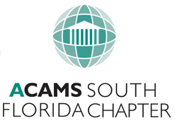

As evidenced by record anti-money laundering (AML) fines and increased prosecutions of fraudsters, prosecutors are rigorously applying both AML and fraud statutes. This one day conference addresses current issues in the world of AML and Fraud. Learn core principles of AML and Fraud taught by leading practitioners, consultants, and investigators (both Fraud/AML Subject Matter Experts).

**Program:**

Mundane No More: Putting Strategic Insight Back into Vendor Management

* Steve Sanders, CSI

KEYNOTE: Wolf of Wall Street Investigation

* Greg Coleman, Coleman Worldwide Advisors

Geographic Targeting Order Expansion

* John Tobon, Department of Homeland Security, ICE

Cybersecurity Presentation & Dark Web Demo

* Robert Villanueva, Q6 Cyber

BITCOIN/Digital Currency Panel

* Robert Villanueva, Q6 Cyber (Moderator)
* Kevin Rosen, Shutts & Bowen
* Rick Arias, Miami Beach Police Department
* Marshall Swatt, Co-Founder of Coinsetter, Inc.

Tracing Assets

* Phil Shechter, Cherry Bekaert
* Marc Hurwitz, Crossroads Investigations

Event Sponsor:

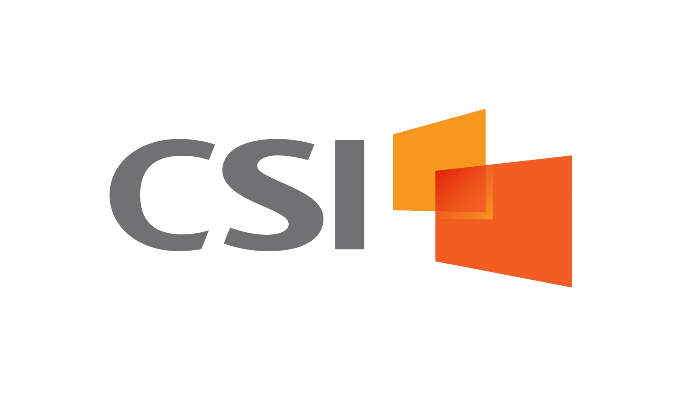

FIU Kovens Conference Center

3000 NE 151 Street

North Miami, FL 33181

Time: 7:30AM – 5:10PM

Registration: 7:30AM – 8:30AM

SFLA Chapter Members: $150

Non-SFLA Chapter Members: $200

Government & Law Enforcement: $75

Students: $75

Group Pricing (4 or more): $125

Registration:

ACFE: [REGISTER HERE](http://southfloridaacfe.org/meetinginfo.php?id=17&ts=1475508377)

ACAMS: [REGISTER HERE](https://acams.secure.force.com/store/Events2?type=Chapter%20Event)

Included w/ Registration:

|  |  |
| --- | --- |
| Free parking | Snacks |
| Coffee breaks | Lunch |

Event is worth:

8 CFE Credits / 8 CAMS Credits

Cancellation Policy: Cancellations must be made prior to the start of the event. No refunds or credits will be given for cancellations received on or after the start of the event.

Not a member of the chapter? Go to [ACFE](http://southfloridaacfe.org/form.php?form_id=8) or [ACAMS](https://acams.secure.force.com/store/Products2?type=Chapters) to join!